Ex:No: 10

Date:

**Simple programming exercise using(REPEAT, WHILE )**

**Aim:**

To learn how to use various MySQL loop statements including while, repeat to run a block of code repeatedly based on a condition.

**Program1**

Write a function to build a string repeatedly until the value of the variable becomes s greater than 5. Then, we display the final string using a SELECT statement.

**Program 2:**

Write a function that uses REPEAT statement which would repeat the loop until income is greater than or equal to 4000, at which point the REPEAT loop would beterminated

**OUTPUTS:**

**Program1:**

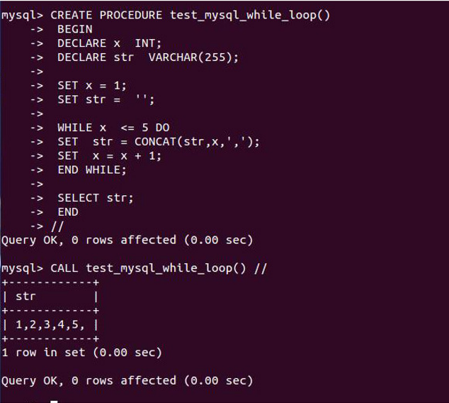

**Program 2:**

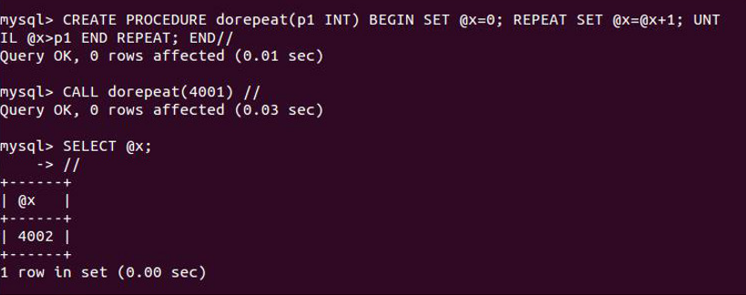

**RESULT :**Thus the Simple programming exercise using(REPEAT, WHILE ) exectuted successfully.